Voice Controlled Robotic Vehicle

Our proposed project aims at a robotic vehicle operated by human speech commands. The system operates with the use of a android device which transmits voice commands to an 8051 microcontroller to achieve this functionality.
The transmitter consists of the android phone Bluetooth device. The voice commands recognized by the module are transmitted by through the Bluetooth transmitter. These commands are detected by the robotic vehicle in order to move it in left, right, backwards and front directions.
The bluetooth receiver mounted on top of the vehicle is used to recognize the transmitted commands and decode them. After decoding these commands are passed on to the 8051 microcontroller.
The microcontroller then drives the vehicle motors to move it accordingly. This is done with the use of a driver IC used to control the motor movements.
The Bluetooth technology used to transmit and receive data allows for remotely operating the system within a good range.

Block Diagram:

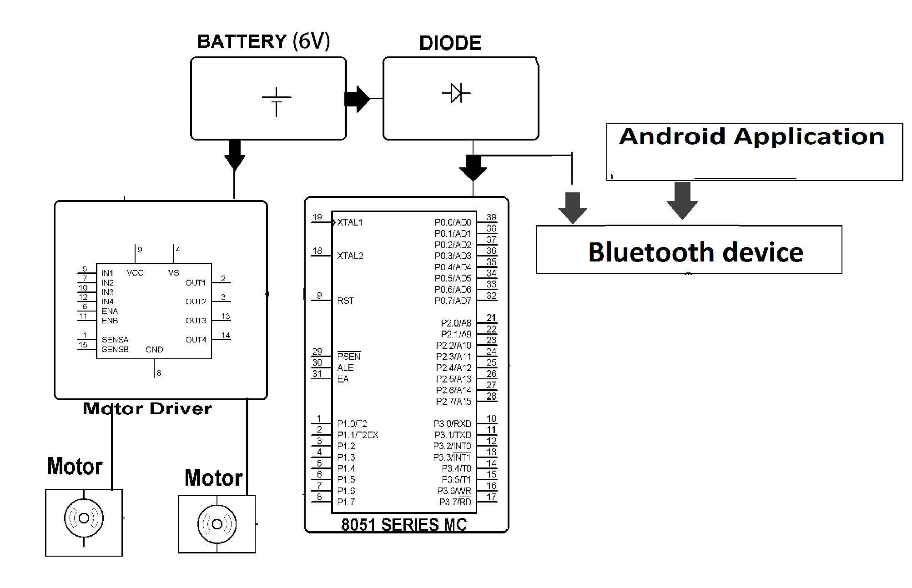

Hardware Specifications
- 8051 series Microcontroller
- Motor Driver IC
- Battery
- DC motors
- Robot Body
- Crystal
- Voltage Regulator
- Bluetooth Device

Software Specifications
- Keil µVision IDE
- MC Programming Language: Embedded C
Bluetooth Overview

Hardware features
Typical -80dBm sensitivity
Up to +4dBm RF transmit power
Low Power 1.8V Operation ,1.8 to 3.6V I/O
PIO control
UART interface with programmable baud rate
With integrated antenna
With edge connector

- Wireless technology for short-range voice and data communication
- Low-cost and low-power
- Provides a communication platform between a wide range of “smart” devices
- Not limited to “line of sight” communication

It is preferable to use bluetooth because nowadays people have their smartphones with them all the time, since the smartphones have bluetooth facility in them, thus it's better to use bluetooth rather than using RF remotes or IR remotes. Have you ever seen people carrying remotes???
Using bluetooth has many of its own advantages :
1.It's secure.
2.Easy to use.
3.It works in short distance range(i.e. upto 10mtrs.)
4.Anyone can find free bluetooth apps on android and many more.

Reference
- http://ieeexplore.ieee.org/xpl/articleDetails.jsp?arnumber=7095886&queryText=voice%20controlled%20vehicle&newsearch=true

